3 More Flex-Box Properties

Simple Centering

Flex Direction

What does >* mean

The wrap property with gap and >*

The gap property

The justify-content property

The align-items property

Understanding the flex-grow, flex-shrink and flex basis

The order property

## Parent -Child Relationship

With Flex-box you are working with a parent (the container) and the child or children (individual div or elements in the container). You always want to throw your children into the parent. The parent will have the flex property attached to it; the children will not have the flex property attached to it. They just flex because their parent told them to.

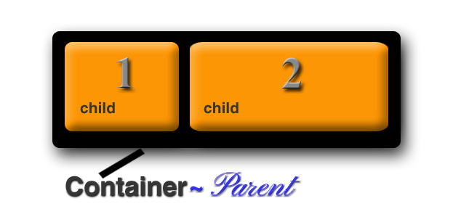

## Now for some examples:

## Simple centering

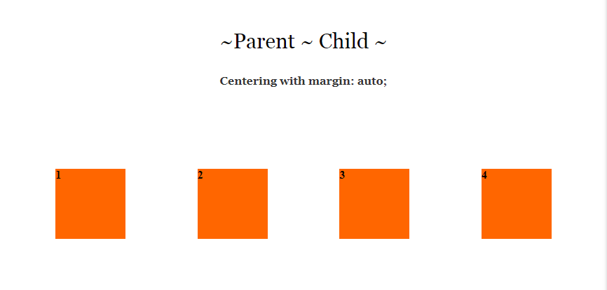

## Flex Direction

Instead of using display, as the property for the container, we could change it to fle. The flex-direction takes a few attributes. Think of the flex container as something that will lay out its elements in either a horizontal, or a vertical direction. In other words, in either a row, or a column.

So, we can use row, or column. But then flex wants to give us just a bit more, and throws in a way in which we can reverse the items that we specify for each one of them so, we can do this:

* row (default)
* row-reverse
* column
* column-reverse

Since row is the default, let’s try using one of these techniques and set the flex-direction to be column, and see how that works. As we work further in this tutorial, we will be working on putting some space between those boxes.

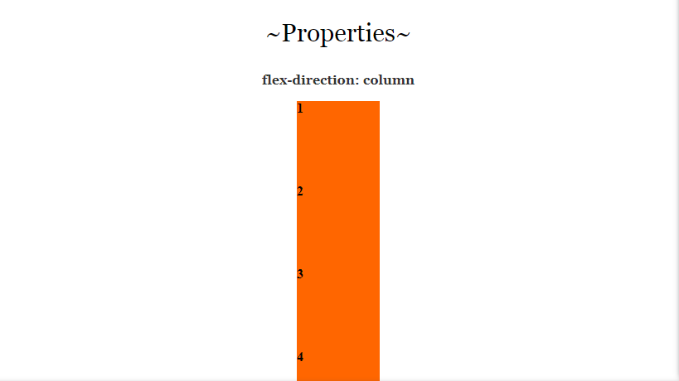

You might want to add some height to the containers so the column doesn’t look stuck to the bottom of the page.

## What does > * mean when working with flexbox?

The **>** sign indicates that the container wants to talk to its children. So, when you see a **>** think listen up kids I am talking to you. In this case the container is talking to all of the **div** tags it has inside of it. In this case the kids have a class of .box.

Now the star **\*** after the **>** sign means that the parent wants to talk to **ALL** of its children. So, in this case in the CSS, we are writing code that all of the kids, or **div.boxes** have to adhere to.

## The wrap property, with Gap and >*

I needed to explain that >* because the wrap property, all though useful can be quite a finicky fella.

### The wrap property

You will find that by default when you set the container to flex, everything will try to fit on the same row, but that isn’t exactly the behavior that you might want, sometime you want your boxes to wrap around. Go here to learn about the **gap** property, here to learn about the **justify-content** property, and here to learn about **what those numbers mean** after the **>\***.

You put the flex-wrap on the container. It has 3 different settings.

* nowrap (default) all items on same line
* wrap: will wrap around top top bottom
* wrap-reverse: will wrap around bottom to top

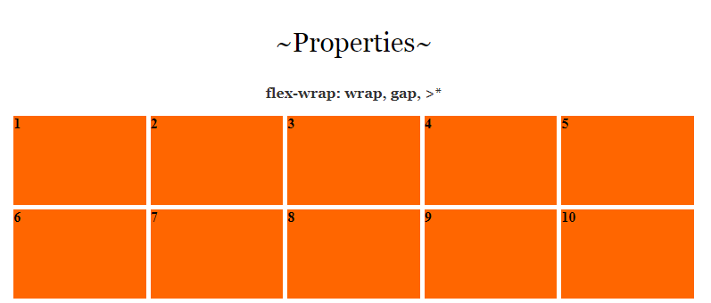

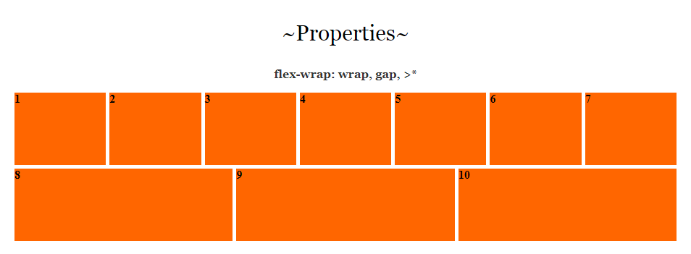

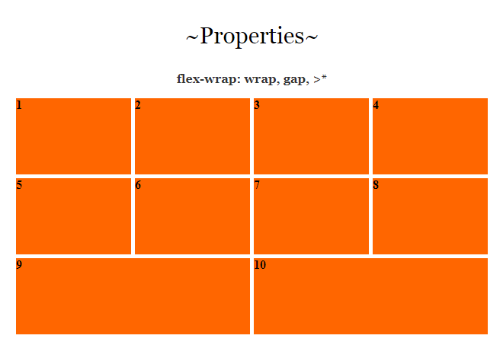

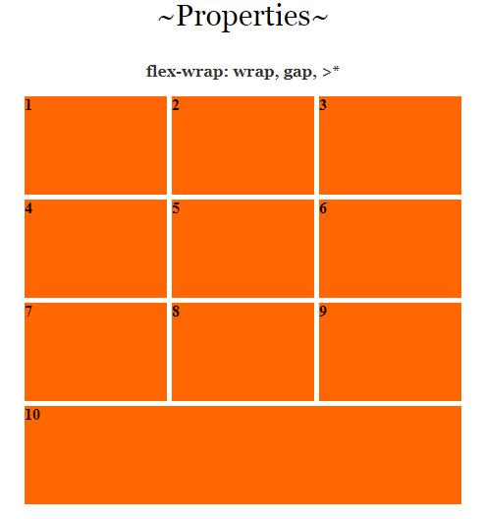

### Gap Property

The **gap** property is what we can use to put the space in-between the boxes. This can be set to any thing that you want, but I just set mine to be 5 px. It doesn’t add any space around the outside edges of the boxes.

.container {

display: flex;

}

You can set the container gap to be any of the following. The size of the gap is up to you. As you can see, the first one will set a gap for row and gap all in one setting, if you want the row and the column to be different settings, you would use the second example below. Or, you could just sett the row and column separately as demonstrated in the last two lines of code.

**Gap: 5px;**

**gap: 5px 20px; /* row-gap column gap */**

**row-gap: 5px;**

**column-gap: 5px;**



### Justify Content

The justify-content is what you would use when you want to define the alinement of your boxes along the main axis. You would put this on the parent element, or in our case the .container. It has 6 different settings. Some browsers are not in full compliance with this property just yet, but for the most part, you can use it.

Flex-start

Flex-end

Center

Space-between

Space-around

Space-evenly

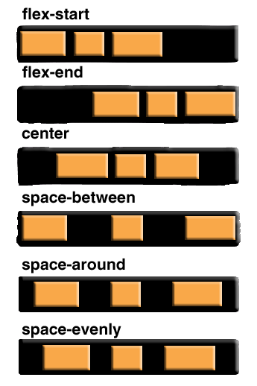

### Justify content:flex end

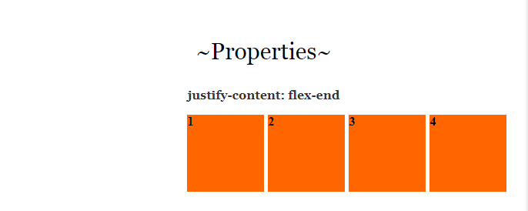

In order to make this work, we will have to remove that auto setting on the margin, because that will just center everything.

## Space-between

If you use space-between the space inbetween each box will become either wider or narrower, depending on the width of the page.

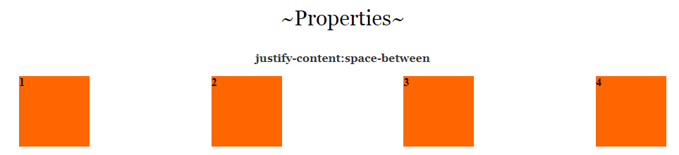

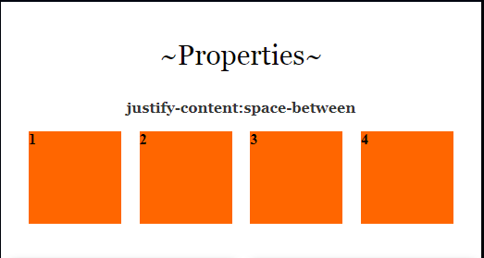

## HTML

<div class="container">

<div class="box"> 1 </div>

<div class="box"> 2 </div>

<div class="box"> 3 </div>

<div class="box"> 4 </div>

</div>

## CSS

.box {

width: 100px; /* This can be anything */

height: 100px; /* This can be anything */

background-color:#F60;

}

.container {

display: flex;

justify-content: space-between;

gap: 5px;

}

### The difference between justify-content and align -items

Justify-content controls all of the items that are placed on the main axis, align-items will control all of the items on the cross axis. So, the difference between moving items right, and left, and up and down, on your web page.

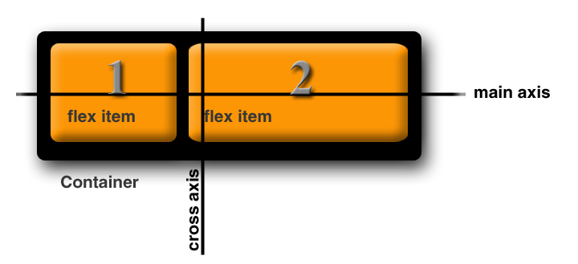

## Align Items

The align-items property will decide the behavior of how items are arranged on the cross axis.

flex-start

flex-end

center

baseline

first baseline

last baseline

start

end

self-start

self-end

+… safe | unsafe;

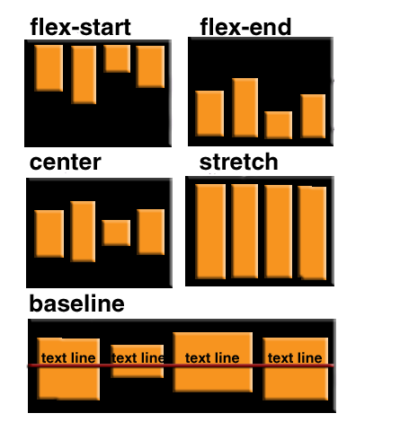

Again, you will be adding this property to the container or parent object.

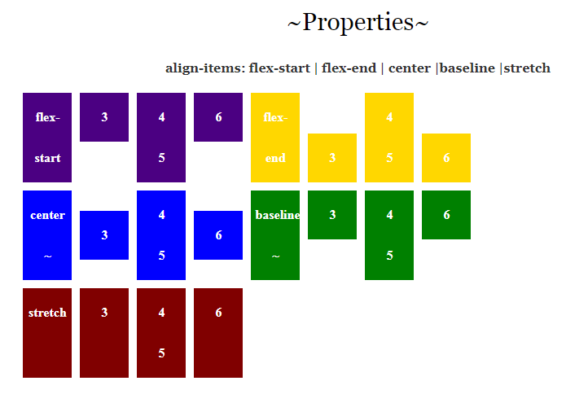

The code for the above is just a bit more complicated because none of the browsers seem to want to play nice with it, so we have to make code to accommodate a lot of them. To see the code for the html and CSS you can go [here](Extra-Files/Align%20Items%20HTML%20and%20CSS%20Examples.docx).

## Align Items example 2

Align Items is a way in which you can align elements on the cross axis. This would be the up-down or vertical alignment.

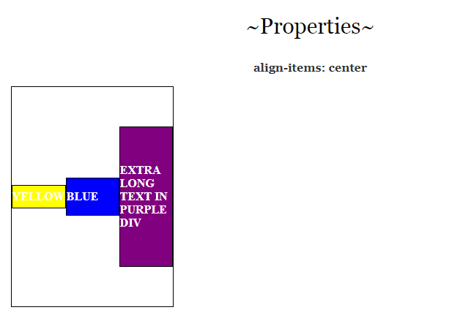

Now look at the CSS, where we used the >* remember by using this on the style rule, we are able to target all of the div’s (children) inside of the container which is the parent. We also used a flex of 1. Setting it to flex: 1 means that

## HTML

<div class="container" >

<div class= "box1">YELLOW</div>

<div class= "box2">BLUE</div>

<div class= "box3">EXTRA LONG TEXT IN PURPLE DIV</div>

</div>

## CSS

## .container {

## width: 220px;

## height: 300px;

## border: 1px solid black;

## display: flex;

## align-items: center;

## }

## .box1 {

## background-color:yellow;

## min-height:30px;

## }

## .box2 {

## background-color:blue;

## min-height:50px;

## }

## .box3 {

## background-color:purple;

## min-height:190px;

## }

## .container >* {

## flex: 1;

## border: 1px solid black;

## display: flex;

## align-items: center;

## 

## 

## }

## Understanding the flex-grow, flex-shrink and flex basis

You may have noticed in an example that we had above that we used some numbers after we used our shorthand of >* to talk to the children of the container. Here I will explain what those numbers mean.

The child div’s of the container will come with some default properties. We may not see them, but they are there. This doesn’t mean that we can not overwrite them if we wanted to do so. One such property is the:

**flex: 0 1 auto**

This is the default flex value. These numbers are a sort of shorthand, and what they are doing is setting 3 values at the same time.

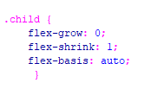

You can think of this rule like this:

.child {

flex: [flex-grow] [flex-shrink] [flex-basis];

}

/* or... */

.child {

flex: [max] [min] [ideal size];

}

So, when we set our first setting to 0, we are telling flex that we do not want our div’s to grow any larger, that 2nd setting is how much we want our divs to shrink. Since we want it to be responsive and shrink for something like a cell phone size, this setting is specified as 1. Then our final setting is what our idea size for this div would be. As you can imagine, you can change these numbers, and the one that you might want to change the majority of the time would be your idea size for your div. And as I said, that would be your last setting.

In the example, below I wrote out the full code for the grow, shrink and basis property, but flex actually would prefer you to use shorthand. So, you should do your work to look more like this:

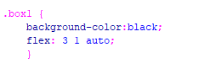

Now to see this one in action you will want to stretch out your page and bring it back to a cell phone size. The illustration below is just an image, you need to play with these settings your self and see what they do.

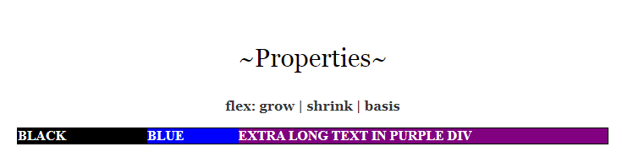

You can use these settings for starters

## HTML

<div class="container" >

<div class= "box1">BLACK</div>

<div class= "box2">BLUE</div>

<div class= "box3">EXTRA LONG TEXT IN PURPLE DIV</div>

</div>

## CSS

.container {

border: 1px solid black;

display: flex;

}

.box1 {

background-color:black;

flex-grow: 3;

flex-shrink: 1;

flex-basis: auto;

}

.box2 {

background-color:blue;

flex-grow: 2;

flex-shrink: 1;

flex-basis: 300;

}

.box3 {

background-color:purple;

flex-grow: 5;

flex-shrink: 1;

flex-basis: 150;

}

.container >* {

color: white;

}

## Order

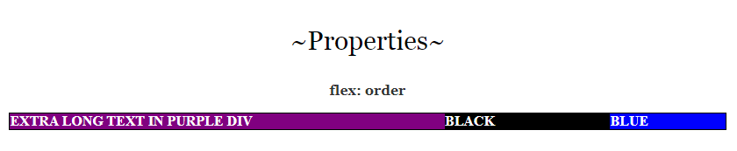

The last property that we will be looking at will be the order property. By default, what ever way that you lay out your divs in your HTML will be the way that your layout will be, but you can change that to have your divs be laid out on your page in a different way then what you have in your HTML code. And this little behavior can be a bit of fun.

## HTML

<div class="container" >

<div class= "box1">BLACK</div>

<div class= "box2">BLUE</div>

<div class= "box3">EXTRA LONG TEXT IN PURPLE DIV</div>

</div>

## CSS

.container {

border: 1px solid black;

display: flex;

}

.box1 {

background-color:black;

flex: 3 1 auto;

order: 2;

}

.box2 {

background-color:blue;

flex-grow: 2;

flex-shrink: 1;

flex-basis: 300;

order: 3;

}

.box3 {

background-color:purple;

flex-grow: 5;

flex-shrink: 1;

flex-basis: 150;

order: 1;

}

.container >* {

color: white;

}